Tel: 956-216-5401

Harlingen Police Department
1018 Fair Park Blvd.
Harlingen, Texas 78550

Implementing the DDACTS Model

DDACTS relies on seven guiding principles for its implementation.

- Partners and Stakeholders Participation
- Data Collection
- Data Analysis
- Strategic Operations
- Information Sharing and Outreach
- Monitoring, Evaluation, and Adjustments
- Outcomes

The implementation outlines procedures, and highlights operational considerations based on best practices in the field for each of the seven guiding principles. Starting with building community partnerships to establish support for highly visible traffic enforcement and to obtain participation that will aid the development of strategic countermeasures and operational plan, DDACTS is based on local data collection and analysis to identify crime, crash, and traffic-related “Hot Spots.” As law enforcement agencies execute these plans, routine information-sharing sessions with stakeholders reinforce the collective ownership of the DDACTS initiative. Finally, monitoring, evaluation, and the analysis of outcome measures provide data-driven feedback for adjustments to internal and external activities.

Data-Driven Approaches
to
Crime and Traffic Safety

(DDACTS)

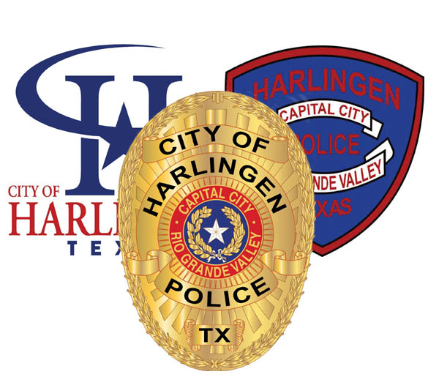

A Starting Point for Long-Term Change

- Law enforcement agencies must collaborate and keep pace with other public and private service sectors that are turning to information technology to assess needs, deliver services, and manage costs.

- Community-focused, place-based law enforcement has emerged as an effective strategy for addressing current issues of social harm and concerns for public safety.

- Finally, because a shortage of law enforcement resources is likely to continue in the foreseeable future, police executives should continue to explore new strategies to further improve quality of life in communities that suffer from the effects of high crime and crash rates.

What is DDACTS?

The Emergence of Data-Driven Policing
DDACTS follows and builds on several developments in policing over the past 30 years, in each of which the use of data to drive police operations is central. These developments include directed patrol, problem-oriented policing, and Compstat.

Directed Patrol
Directed patrol, which was introduced more than thirty years ago, involves the deployment of police resources to high-risk targets.

Problem-Oriented Policing
Problem-solving, as the term is now used in police circles, is a process that focuses attention on constellations of related incidents – “problems” – and the conditions that contribute to them, on the plausible assumption that if one or more of the conditions can be changed, the problem may be ameliorated or even solved entirely

Compstat
Compstat is an administrative innovation introduced as part of the “reengineering” of the New York City Police Department brought by Commissioner William Bratton, in the mid-1990s. Commissioner Bratton gave precinct commanders more authority to develop operational plans and to allocate their resources accordingly, and through Compstat, they were held accountable for using their authority to achieve crime-reduction results.

Data-Driven Approaches to Crime and Traffic Safety (DDACTS) integrates location-based crime and traffic data to establish effective and efficient methods for deploying law enforcement and other resources.
Using geo-mapping to identify areas that have high incidences of crime and crashes, DDACTS uses traffic enforcement strategies that play a dual role in fighting crime and reducing crashes and traffic violations.
Drawing on the deterrent of highly visible traffic enforcement and the knowledge that crime often involves the use of motor vehicles, the goal of DDACTS is to reduce the incidence of crime, crashes, and traffic violations across the country.
DDACTS relies on prompt collection and analysis of crash and crime data to provide actionable reports that inform tactical and strategic decisions of a law enforcement agency.

Implementation of DDACTS is a starting point for executing long-term change in which law enforcement professionals take a more integrated approach to the deployment of personnel and resources. The following presumptions about the future of law enforcement support the necessity for implementing DDACTS:

- Resources allocated for law enforcement activities are frequently not sufficient to keep pace with the demands placed on agencies to respond to calls for service and threats to public safety.

- Decreasing social harm and improving quality of life for communities continue to be primary missions of law enforcement agencies.

- The need for police executives to provide timely and accurate data to justify expenditures and deployment decisions will only increase as Federal, State, and local officials, along with the public, continue to scrutinize the allocation of tax dollars.

- Technology has and will continue to improve the policies and practices of law enforcement. Existing and emerging technologies, such as wireless computers and license plate readers, along with the application of information technology, have greatly enhanced the effectiveness of law enforcement practices.

